HOW TO DELIVER SURPLUS TO SAMM

SAMM is located at 850 S Randolph Way.

You MUST make an appointment to drop off any items. Our hours of operation are7:00 am and 3:00 pm, Monday through Friday. Notice, SAMM is closed for lunch between Noon and 1:00 pm. Please call 520-791-3167 or email SAMM@tucsonaz.gov schedule an appointment.

Please bring:
- A completed and signed Property Transfer form. You can find this form at www.tucsonprocurement.com; click on Departments; click on SAMM (to the left); then click on Property Transfer Form.
- Your confirmation email.
- Your City ID.

HOW TO VIEW AND RESERVE CITY SURPLUS

To view/reserve City Surplus, you MUST set yourself up as a buyer at Public Surplus and you MUST enter in workplace information. (Note: If you are personally set up as a buyer for personal bidding, you must still follow these steps to establish yourself as a buyer for the City of Tucson.)

If you have any questions related to this, please call 520-791-3167or email SAMM@tucsonaz.gov.

Go to www.publicsurplus.com/sms/tucsonaz.gov,az/register/internal

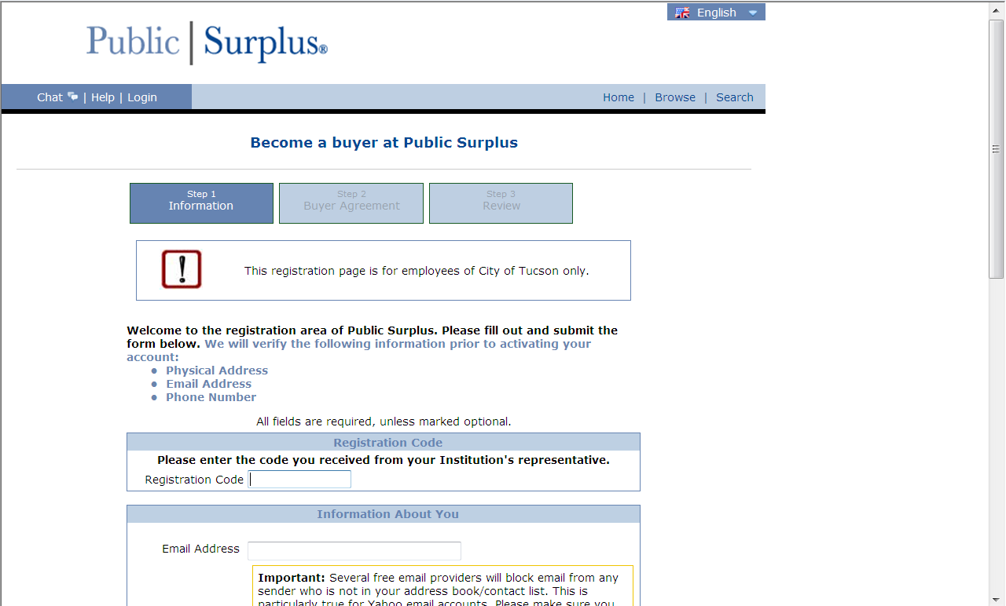

Enter in Registration Code CITE 57 CAM 45
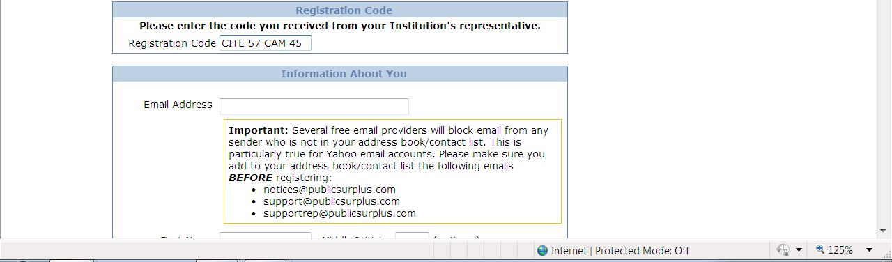

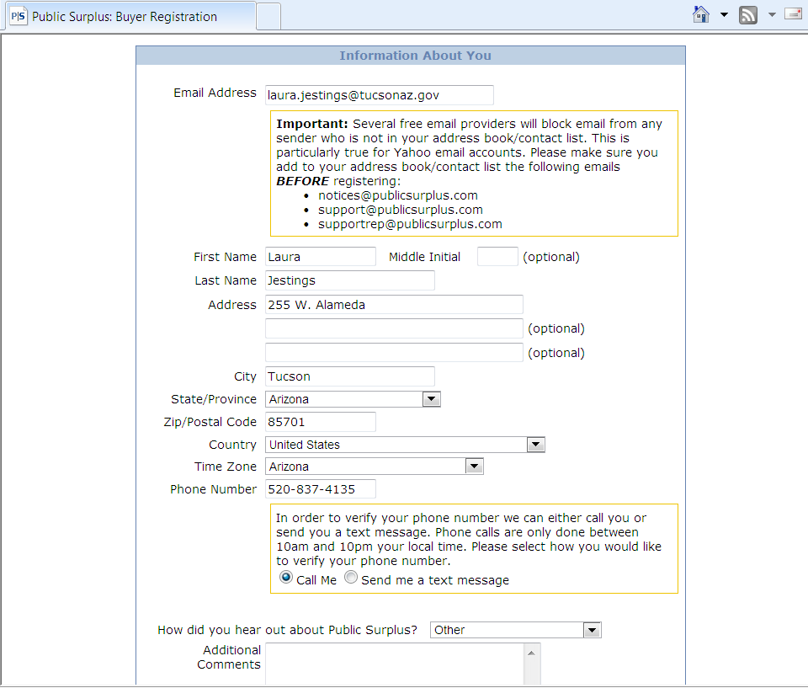
Enter in your City of Tucson email address and your workplace information:

Scroll down and create your user ID and password. Click Next Step.
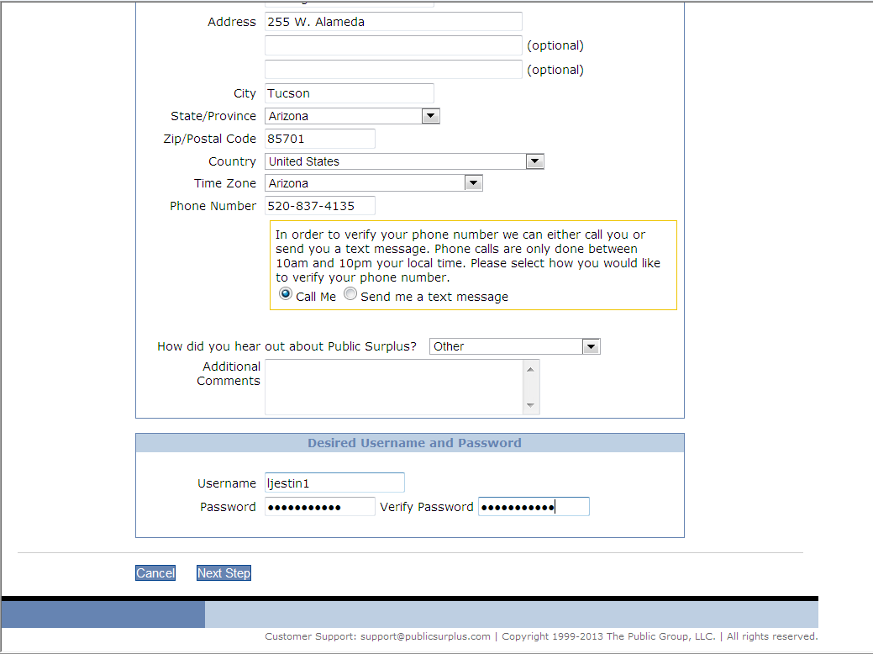

Click “I have read …” and then click Next Step.
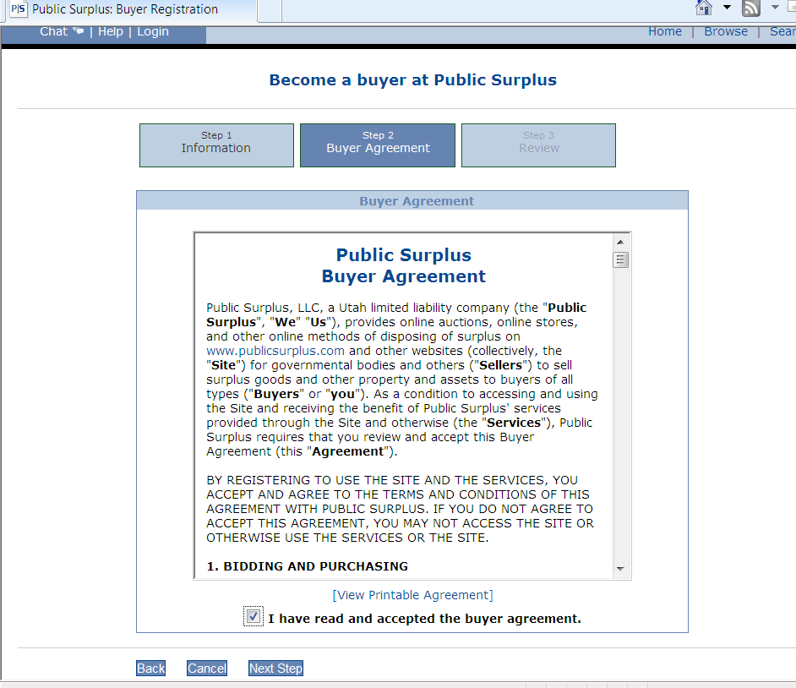

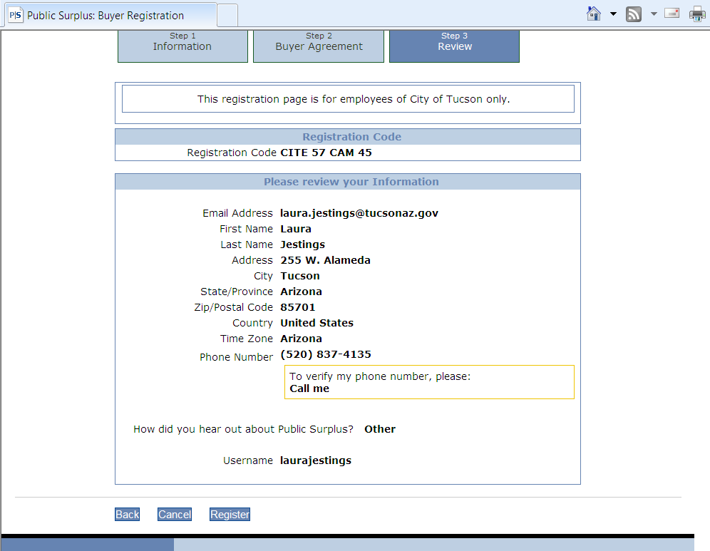
Review your information and then click Register.

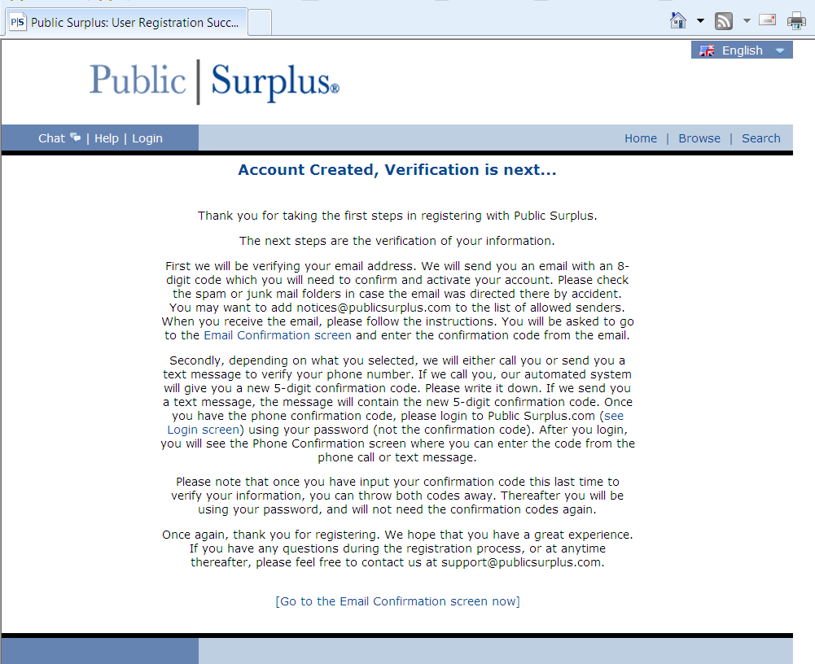
This screen appears. Click “Go to the Email Confirmation screen now.”

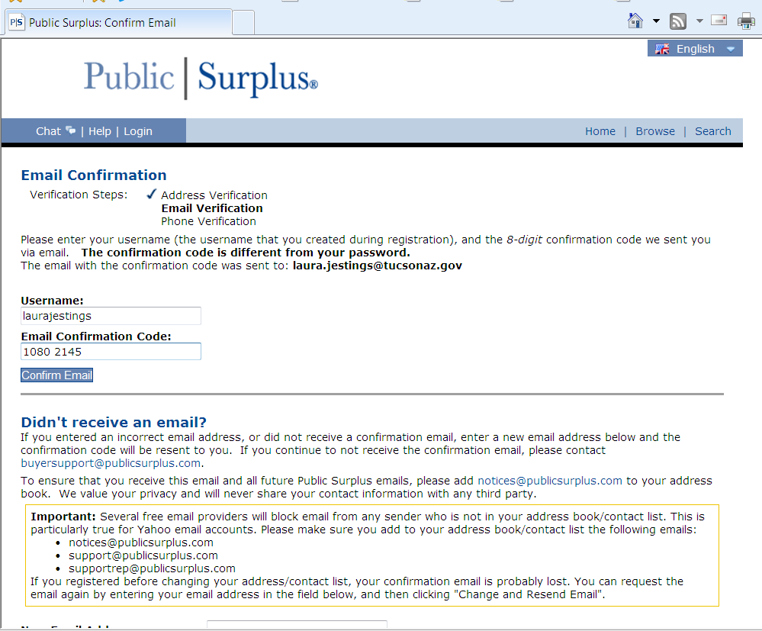
You will receive an Email Confirmation. Enter your code here. Click Confirm Email.

Congratulations! Your account is now open! Let the “bidding” for City Surplus begin!
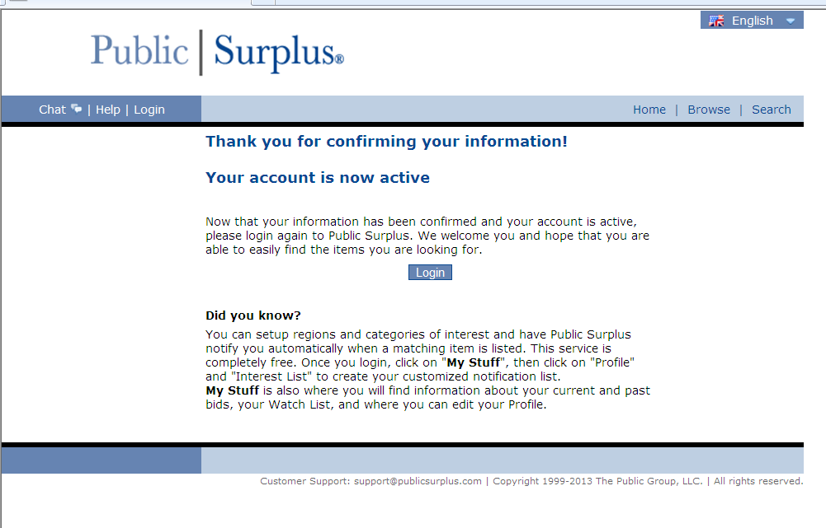

To view City Surplus, click Login.

Log in to the system.
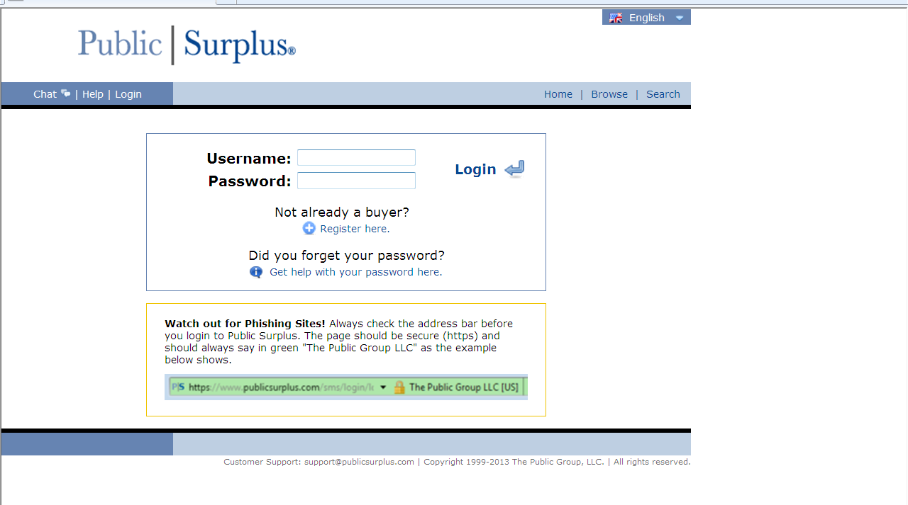

If you are new to Public Surplus’s site, you will see this screen when you log in.
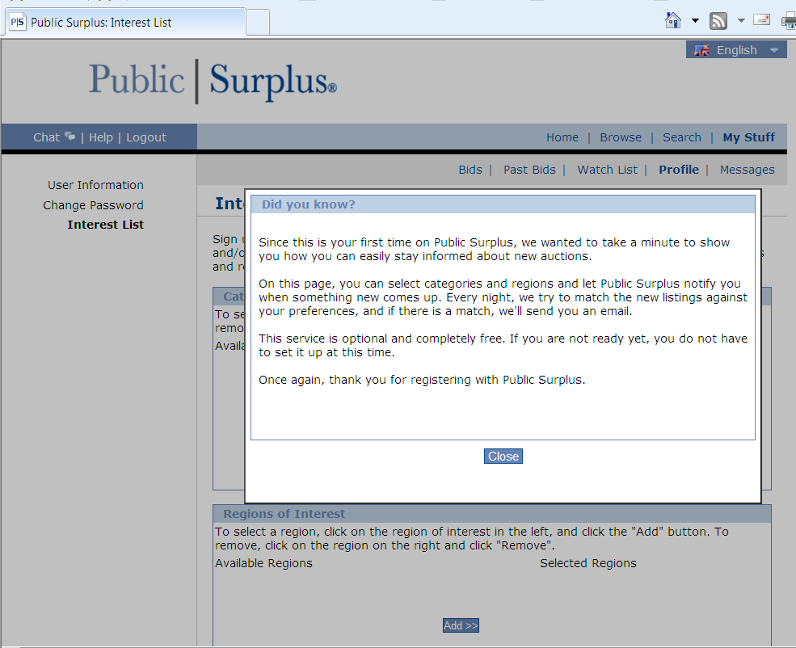

Click “close.”
If you are interested in personally bidding on items that are up for public auction, you can complete an Interest List. For City Surplus purposes, you do not need to complete this. When finished here, click Home.
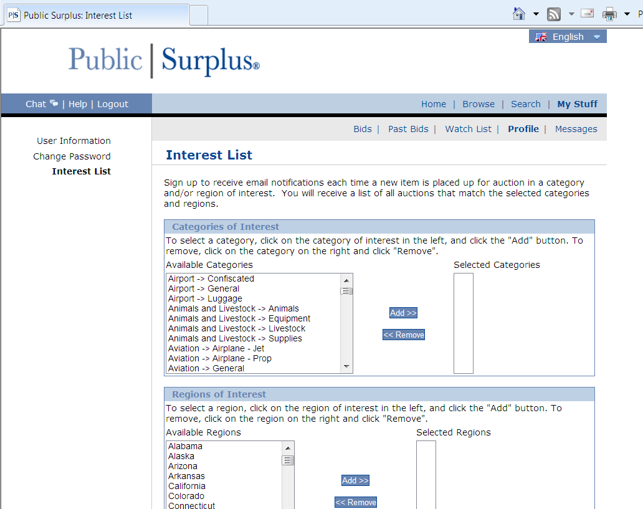

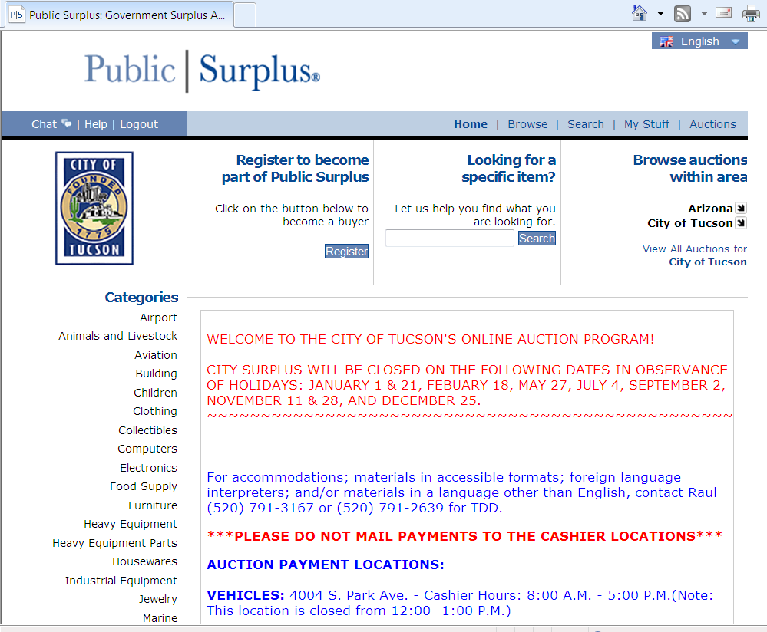
Make sure region is “Arizona” and agency is “City of Tucson.” Click on the arrows if you need to scroll down and select these.

Click on View All Auctions for City of Tucson.
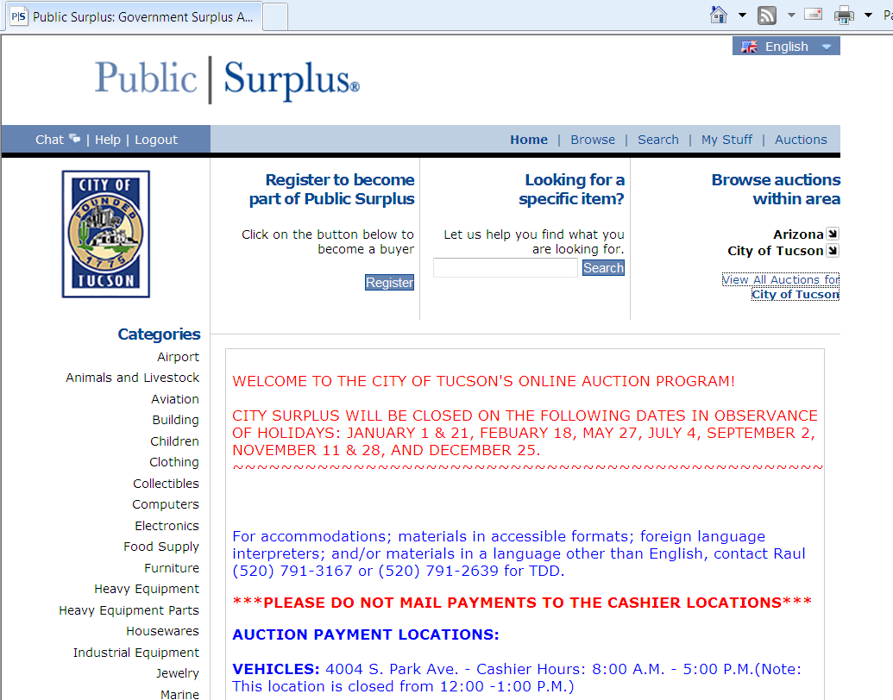

The Current Auctions appear. This contains ALL auctions: Public Auctions Only (i.e., those that anyone can bid on) as well as Internal Auctions Only (i.e., surplus items that only City employees can “bid” on). Select Internal Auctions Only.
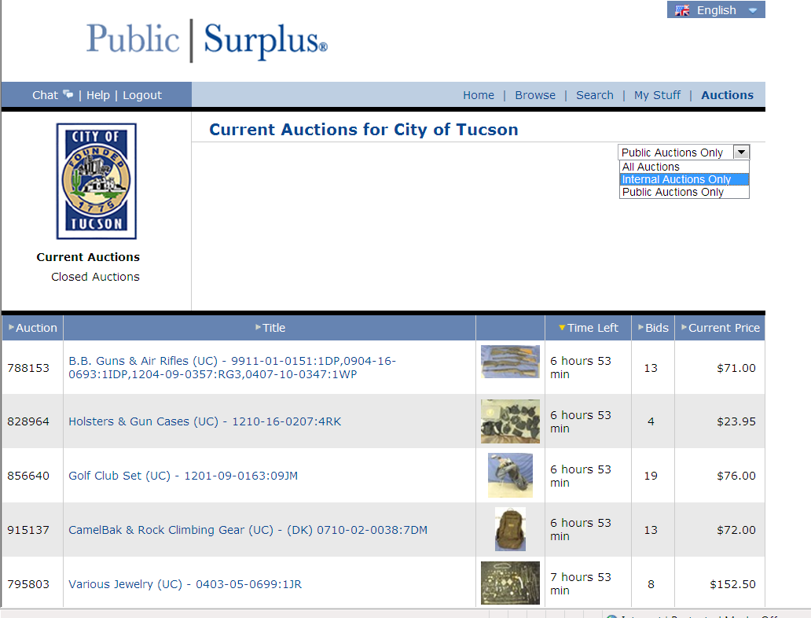

Internal Auctions are always designated by a “key”
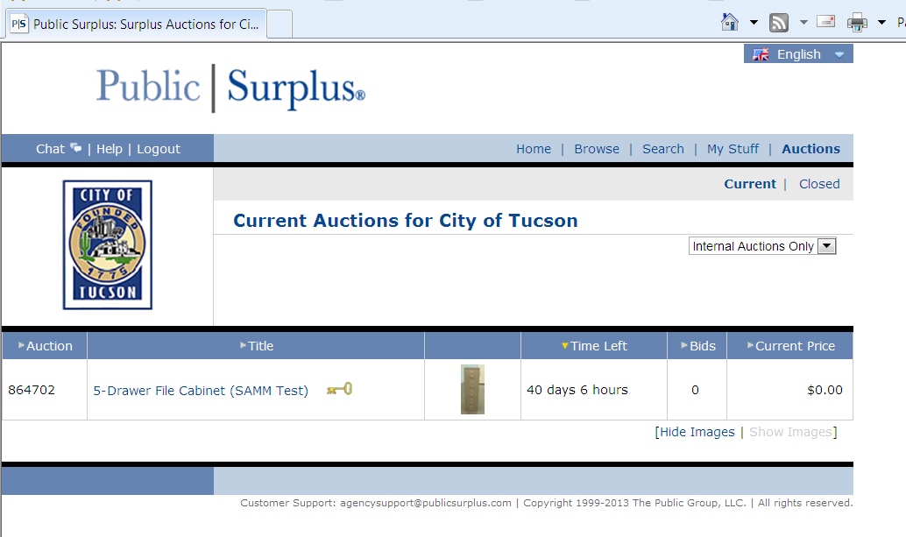

To view the item, click on the photo.
If interested in “bidding” on it, click on the description. Note that the text is geared towards a public bidder. Ignore all of that! It does not apply to City departments “bidding” on City surplus.
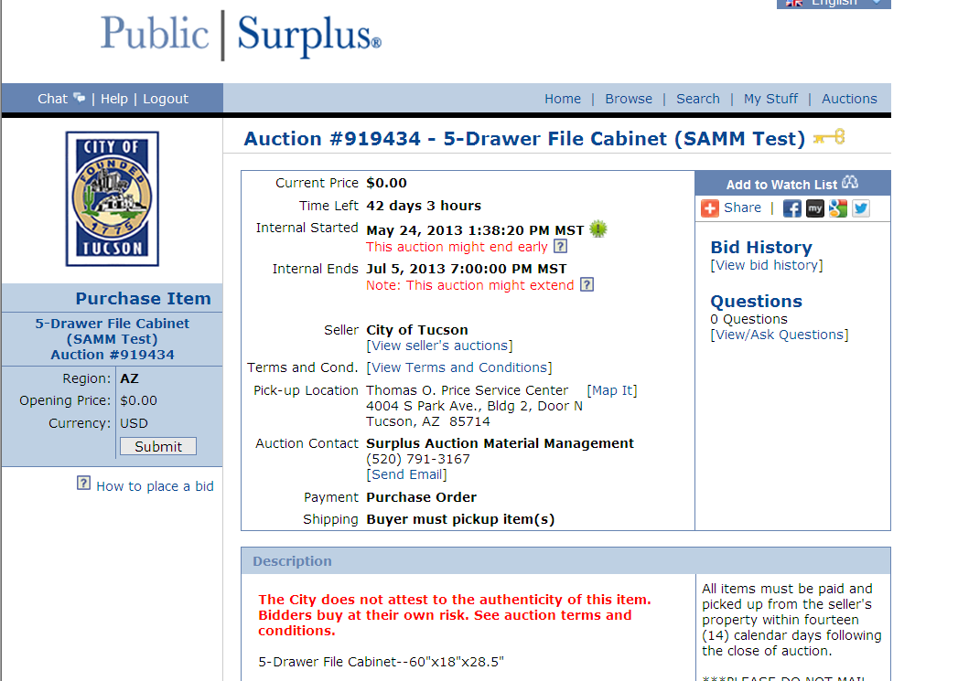

If you want to view the item again, scroll down, and click on the photo.
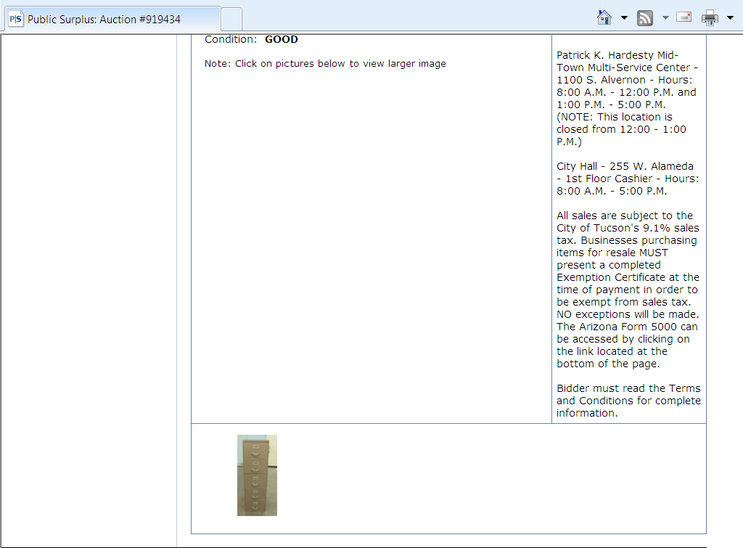

If you want to “bid” on this item (i.e., reserve it for your department), click on Submit.
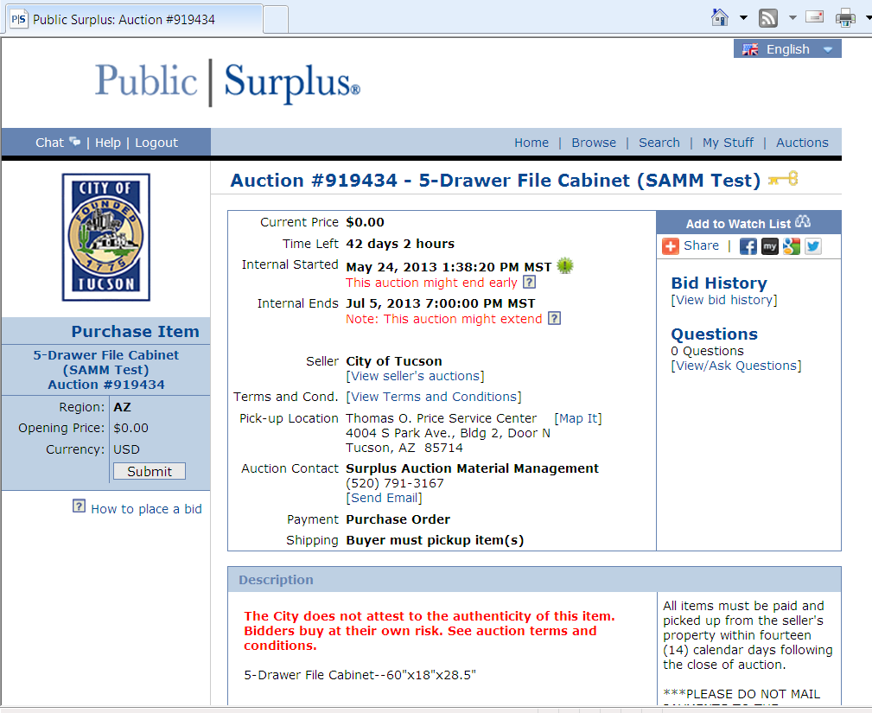

Enter in your department name and your password. Click Confirm Purchase.
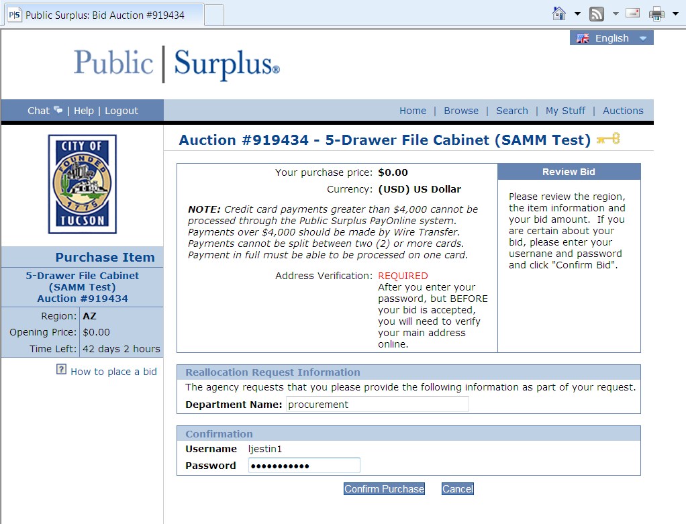

Click Accept.
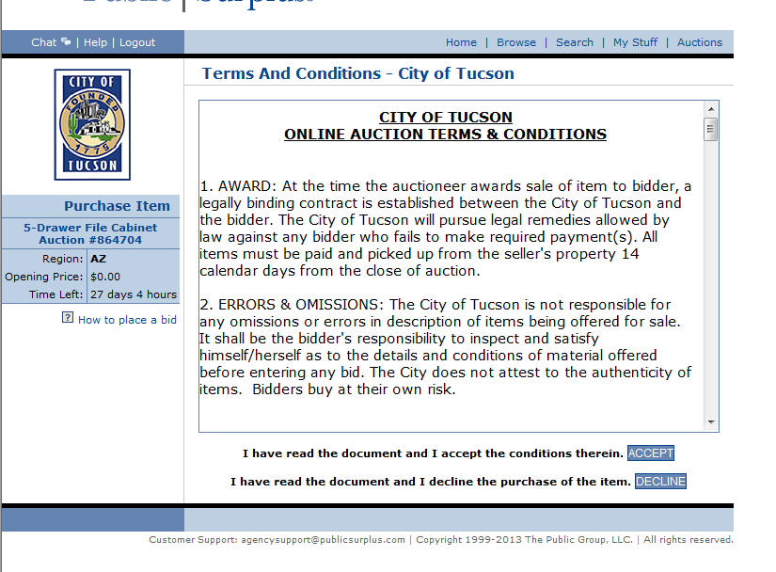

Congratulations! That lovely 5-drawer file cabinet is now reserved for your department! And it fits within your budget at $0 – good job!
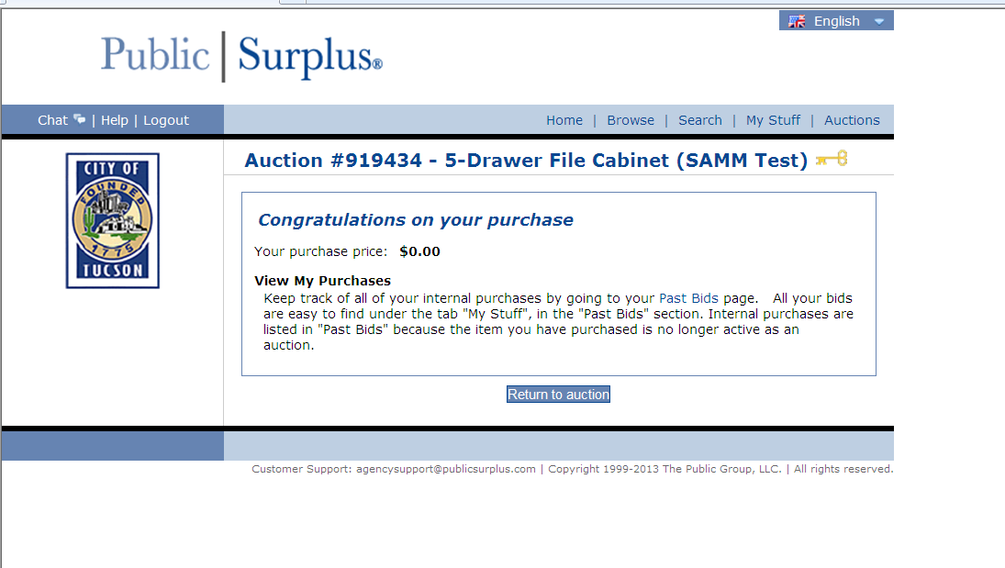

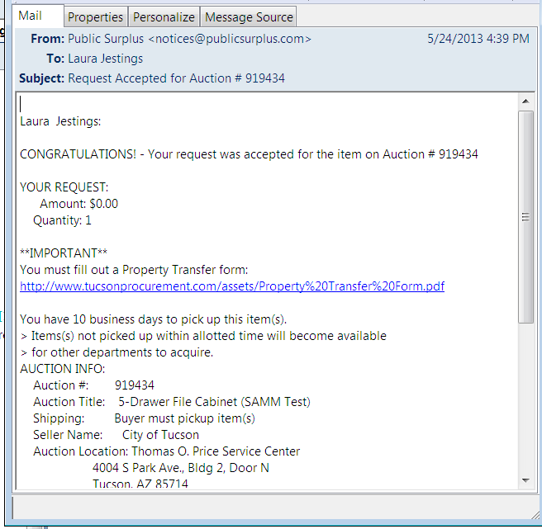
The congratulations keep coming in! Here is your email confirmation of your purchase.

IMPORTANT STEPS ON HOW AND WHEN TO PICK UP YOUR ITEM:
SAMM is located at 850 S Randolph Way.

You MUST make an appointment to pick up your item. Items may be picked up between 7:00 am and 3:00 pm, Monday through Friday. Notice, SAMM is closed for lunch between Noon and 1:00 pm. Please call 520-791-3167 or email SAMM@tucsonaz.gov schedule an appointment.

Please bring:
- A completed and signed Property Transfer form. You can find this form at www.tucsonprocurement.com; click on Departments; click on SAMM (to the left); then click on Property Transfer Form.
- Your confirmation email.
- Your City ID.

SAMM will help load your item, but you are required to bring your own vehicle to transport it back to your department.

Thank you for shopping at SAMM!

